**User Manual**



**“Grievance Redressal Management Information System (GRMIS) – Citizen Portal”**

**Document Version #** 1.1  
**Issue Date:** July 19, 2024.

**Table of Contents**

1 Getting Started 3

1.1 Sign Up 3

1.2 Login 7

1.3 Reset Password 9

2 Using the System 11

2.1 Main Dashboard 11

2.1.1 View Complaint 15

2.1.2 Feedback 16

2.1.3 Appeal 17

2.1.4 Drop Complaint 18

2.2 New Complaint 19

2.3 Update Profile 22

2.4 Change Password 24

2.5 Logout 26

**Table of Figures**

Figure 1: Register Complaint 3

Figure 2: User Sign Up 4

Figure 3: Citizen Registration Form 4

Figure 4: Citizen Registration - Send Code 5

Figure 5: Citizen Registration - OTP Verification 6

Figure 6: Sign Up Successful 6

Figure 7: Citizen Login 7

Figure 8: Wrong Username/Password 8

Figure 9: Forget Password 9

Figure 10: Reset your password 9

Figure 11: Save New Password 10

Figure 12: Main Dashboard 13

Figure 13: My Complaints - 1 14

Figure 14: My Complaints – 2 14

Figure 15:View Complaint 15

Figure 16: Feedback on Complaint 16

Figure 17: Appeal on Complaint 17

Figure 18: Drop Complaint 18

Figure 19: New Complaint 19

Figure 20: Register New Complaint - 1 19

Figure 21: Register New Complaint - 2 20

Figure 22: Register New Complaint – 3 20

Figure 23: Update Profile 22

Figure 24: Update Profile Fields 23

Figure 25: Change Password 24

Figure 26: Enter New Password 25

Figure 27: Logout 26

Figure 28: Confirm Logout 26

# Getting Started

This section provides a general walkthrough of the system.

## Sign Up

User will open the complaint portal and click on the **Register Complaint** at the top right of the web page.

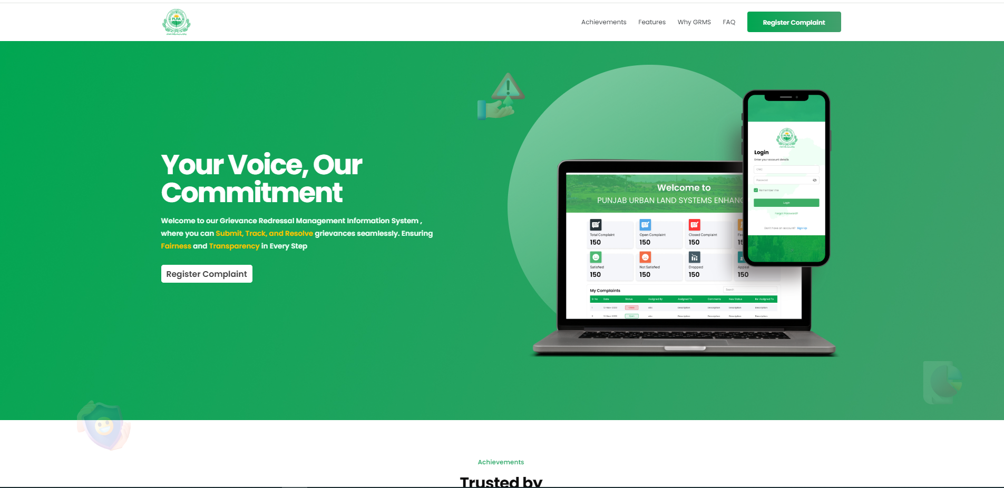

Click here to **register complaint**

Figure 1: Register Complaint

Clicking the **Register Complaint** will redirect the user to the login page as shown below. If the user account has already been created, they can proceed with the sign-in process as explained in Section 1.2: Login. If the user has not created his account yet, he will click on the **Sign-Up** link.

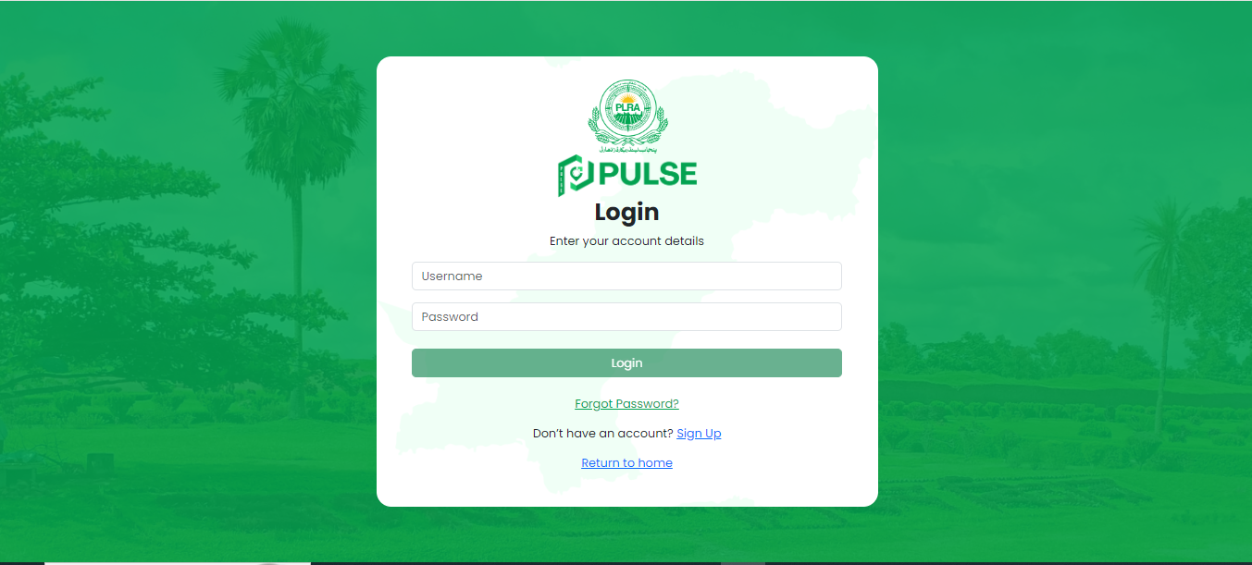

Click here to **create account**

Figure 2: User Sign Up

Clicking the Sign-up link will redirect the user to the registration form as shown below:

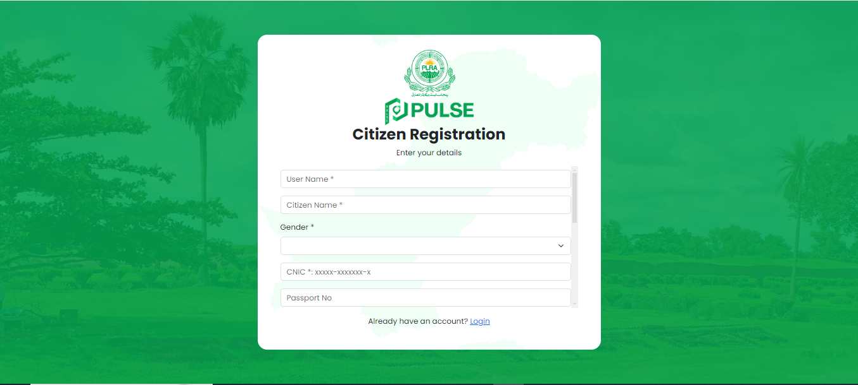

Fill the registration form

Figure 3: Citizen Registration Form

On this page, users will provide the following information to register as a citizen on the PULSE portal:

* Enter **Username** (Mandatory field)
* Enter **Citizen Name** (Mandatory field)
* Select **Gender** (Mandatory field)
* Enter **CNIC** (Mandatory field)
* Enter **Passport No**
* Enter **Phone No**
* Enter **Land Line**
* Enter **Email**
* Enter **Address**
* Enter **Password** (Mandatory field)
* Enter **Confirm Password** (Mandatory field)

Once the user has completely filled out the registration form, they will click on **"Send Code"** to send the verification code to the phone number entered in the form.

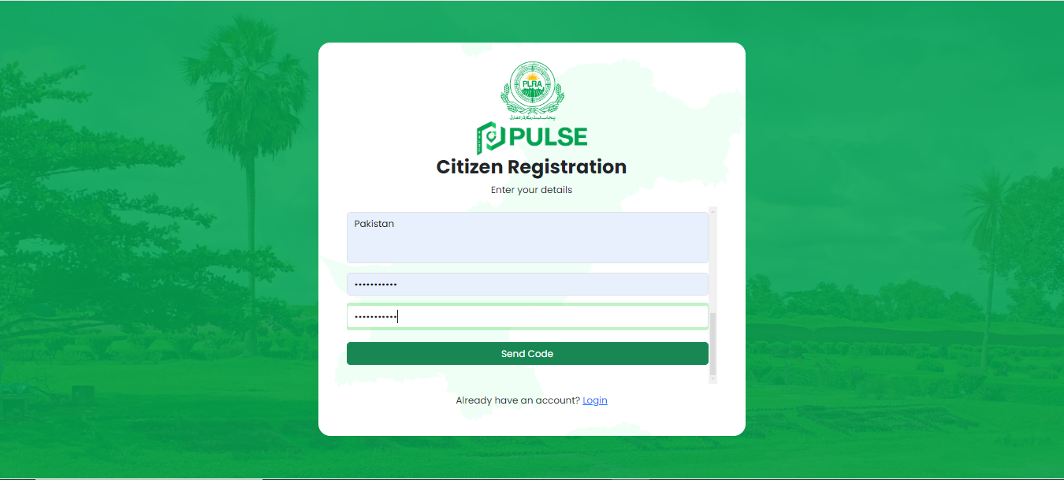

Click here to **Send OTP**

Figure 4: Citizen Registration - Send Code

The user will enter the **6-digit OTP** received on their phone number. If the OTP is not received, the user can resend it when the resend timer is ended.

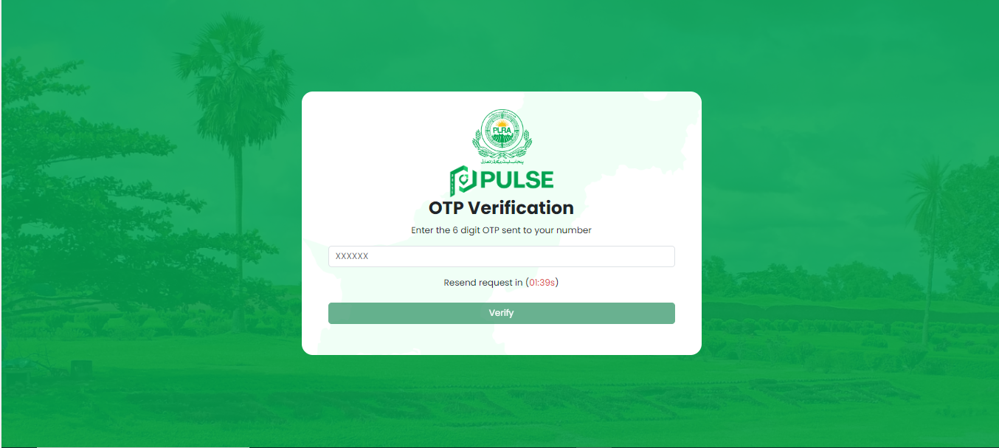

Resend Timer

Enter **OTP**

Click here to **Verify OTP**

Figure 5: Citizen Registration - OTP Verification

Clicking **"Verify"** will initiate the OTP validation process. If successful, a pop-up message will appear confirming a successful signup. The user will click **"OK"** to close the pop-up and sign in with the newly created account.

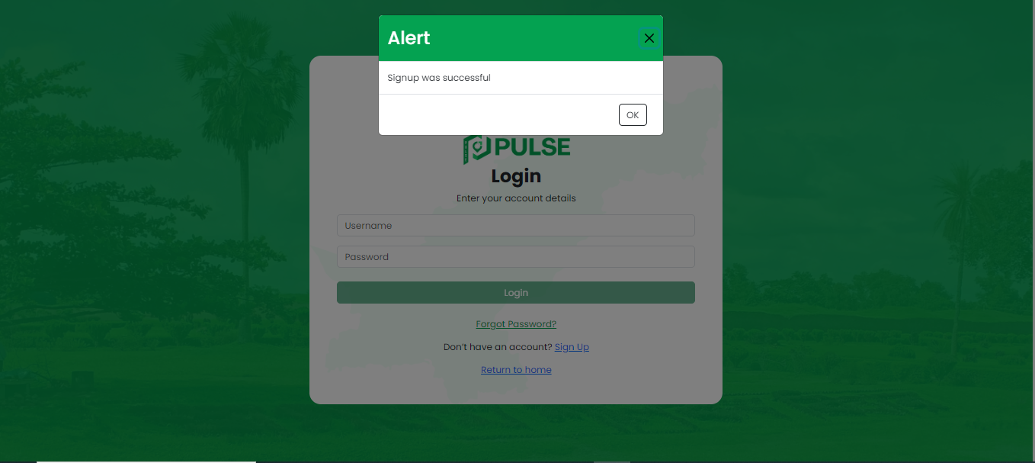

Click here to close pop

Figure 6: Sign Up Successful

## Login

To access the full features and functionalities of the **PULSE** citizen portal, users must sign in to verify their identity as registered citizens.



Click here to return to the **landing page**

Click **Login** to Proceed

Enter **Login Credentials**

Figure 7: Citizen Login

In this interface, the user will enter the following information for login:

* Username
* Password

After entering the information, click on **"Login."** The system will then verify the user's login credentials. If the entered login credentials are invalid, an error message will appear on the screen:

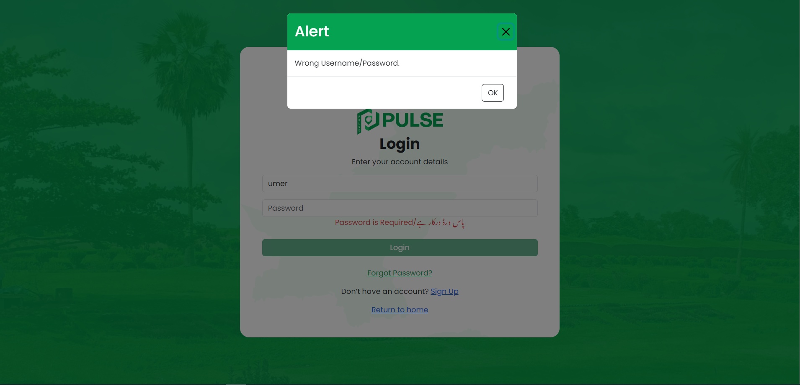

Click here to close alert

Figure 8: Wrong Username/Password

Upon successful verification, the main dashboard of the portal will be displayed, as explained in Section 2.1: Main Dashboard**.**

## Reset Password

If the user forgets their password, they can reset it by clicking on the **"Forgot Password"** link provided on the Login page.



Click here to **Reset Password**

Figure 9: Forget Password

Upon clicking **Forget Password**, reset password screen will be displayed as shown below:

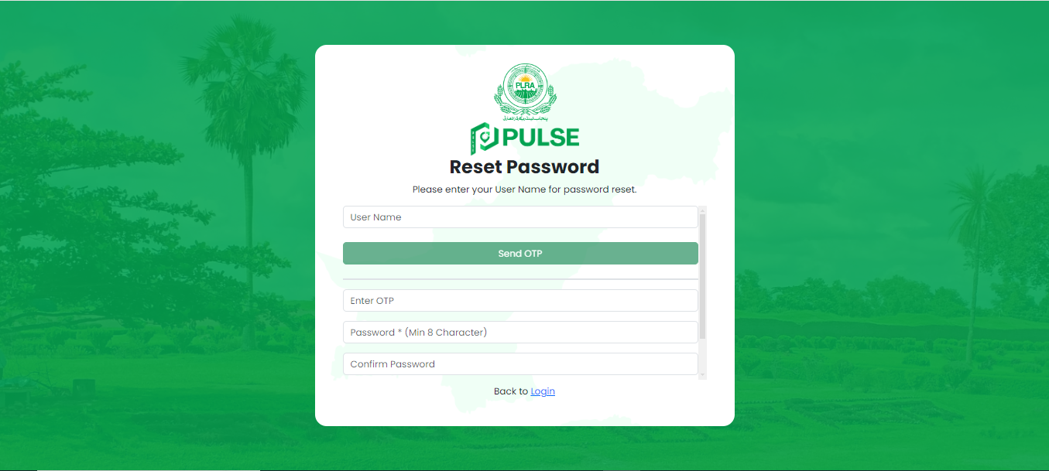

Click here to **Send OTP**

Enter **Required Details**

Figure 10: Reset your password

In this interface, the user will perform the following to reset his password:

* Enter **Username**
* Click on **Send OTP**
* Upon clicking **Send OTP**, verification code will be sent to the user’s mobile number.
* Enter **OTP** (received on the mobile number)
* Enter **New Password** (Min 8 Characters)
* Enter **Confirm Password**
* Click on **Save New Password**

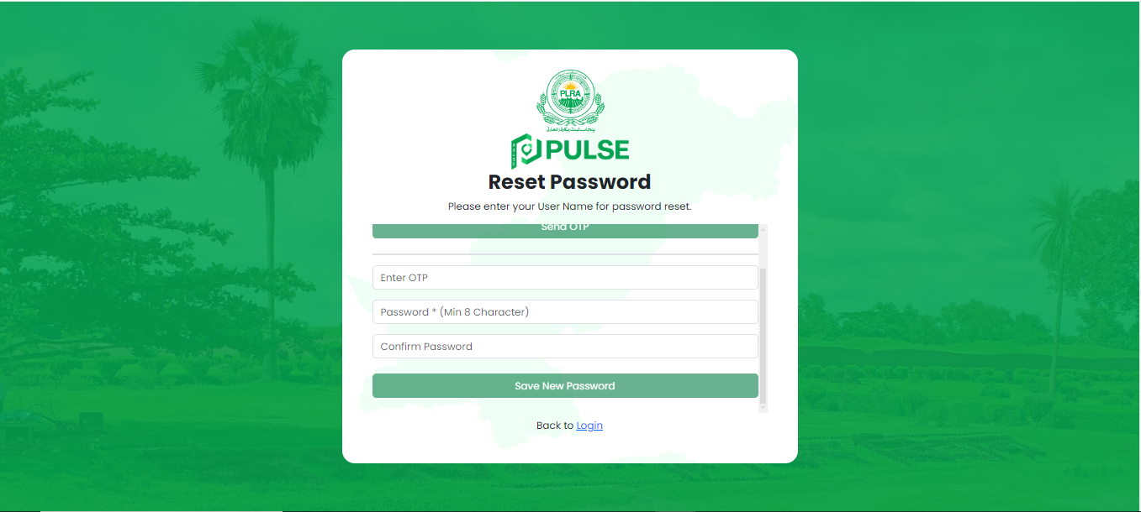

Click here to **Save new password**

Click here togo back to the **login page**

Figure 11: Save New Password

The user's password has been successfully changed. They can now return to the **login page** and access the portal by entering the new password.



# Using the System

## Main Dashboard

Once the login succeeds, main dashboard will be displayed to the user. At the top, you have summary tiles that summarize the status of complaints.

* **Total Complaints**: Shows the total number of complaints received.
* **Open Complaints:** Indicates the number of complaints that are currently open.
* **Closed Complaints:** Displays the number of complaints that have been resolved and closed.
* **Feedback Pending:** The number of pending feedback from citizens on the registered complaints.
* **Satisfied:** Reflects the number of complaints where the complainant was satisfied with the resolution.
* **Not Satisfied:** Counts the complaints where the resolution did not satisfy the citizen.
* **Dropped:** Shows complaints that have been dropped or dismissed.
* **Appeal:** Displays the number of complaints where an appeal has been filed.

In addition to the comprehensive overview of complaints, users can access their complaint history through a well-organized section titled **"My Complaints"**, with the following columns**:**

* Sr No
* Complaint No
* Complaint Type
* Complaint Details
* Status (Following Statuses can be assigned to a complaint)
* **Registered:** This is the initial status assigned to a new complaint submitted by a citizen.
* **Rejected:** Complaints that fall outside the purview of either **PULSE** or **PLRA** will be marked as rejected.
* **Invalid:** Complaints that fall within the domain of **PULSE** or **PLRA** but cannot be processed due to missing information or other issues will be marked as invalid and subsequently dropped.
* **Accepted:** Complaints that can be processed and investigated are considered as accepted complaints.
* **In Progress:** The status changes to "In Progress" when the complaint is assigned to the relevant POC for investigation or action.
* **Resolved:** Once a complaint has been addressed and settled by the relevant POC, its status is marked as "Resolved."
* **Reviewed:** Resolved complaints are reviewed by a designated POC to ensure compliance with regulations and proper resolution procedures. If discrepancies are found, the complaint will be reviewed for further action.
* **Closed:** Complaints that have been addressed and validated as resolved in accordance with regulations are marked as closed.
* **Appeal:** This status indicates that a user has initiated an appeal on a closed complaint. Users can only appeal a closed complaint once.
* **Appeal in Process:** Complaints with appeals under investigation or processing are marked as "Appeal in Process."
* **Appeal Resolved:** Appeals that have been successfully addressed by the relevant POC are marked as "Appeal Resolved."
* **Appeal Reviewed:** Appeals that are not deemed to be resolved in a valid manner will be marked as "Appeal Reviewed" for further investigation.
* **Appeal Closed (Final Status):** Appeals that have been resolved according to established procedures and compliance are marked as **“Appeal Closed”**. This status signifies the final outcome of the respective complaint.
* Action
* View Complaint
* Give Feedback
* Appeal
* Drop Complaint

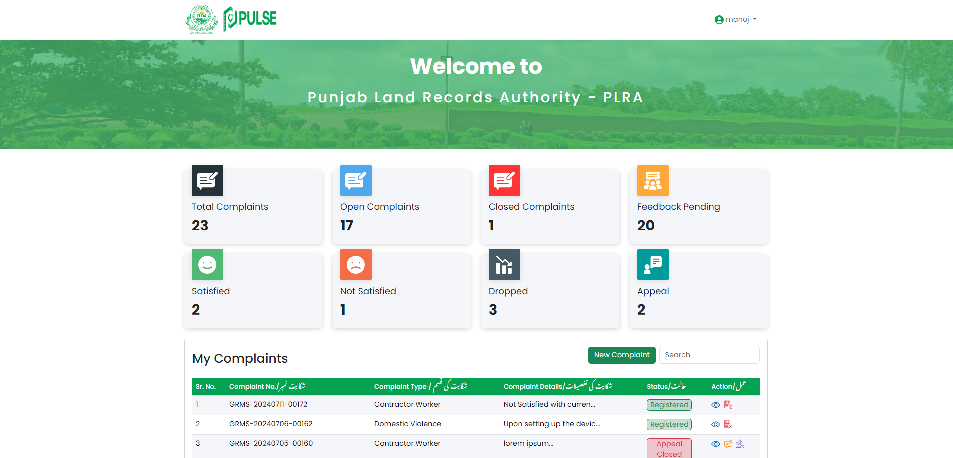

My Complaints

Complaint Summary tiles

Figure 12: Main Dashboard

At the top, there is a search bar to quickly find any specific complaint. User can perform the below actions on the existing complaints:

* View Complaint
* Give Feedback
* Appeal
* Drop Complaint

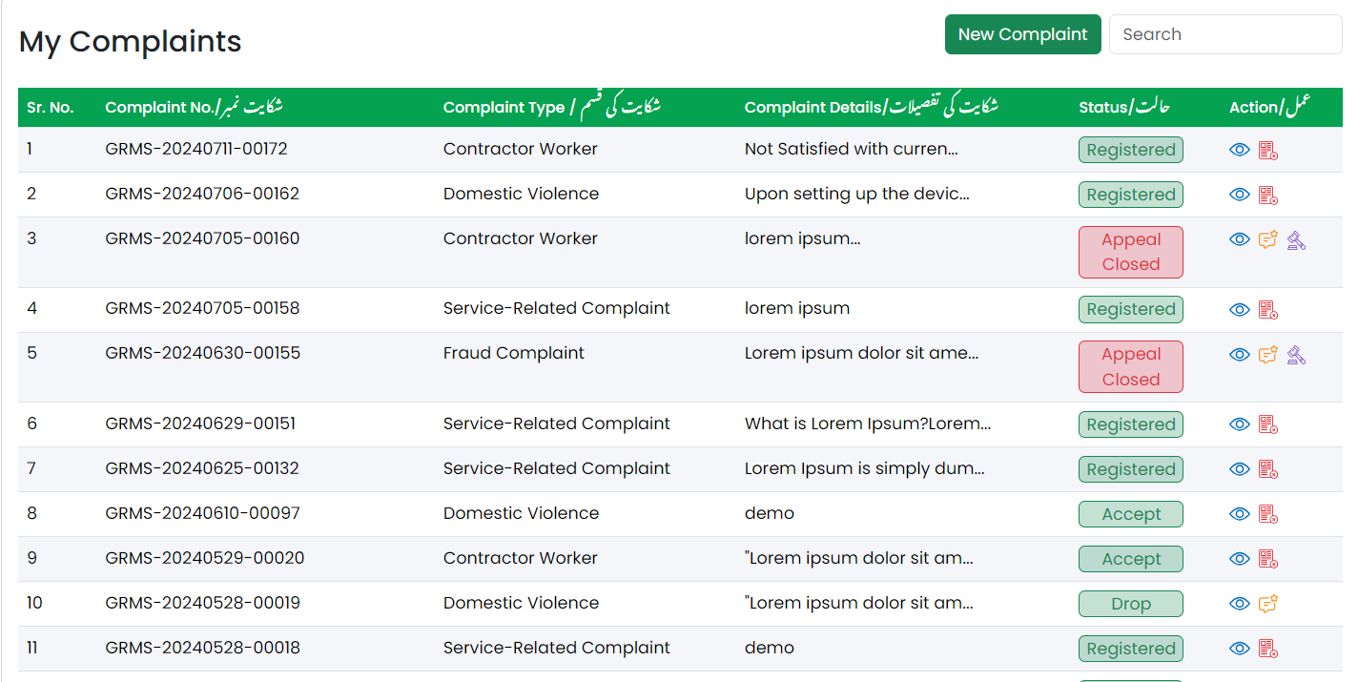

Add Feedback

Appeal on Complaint

Figure 13: My Complaints - 1

Search specific complaint



View Complaint

Drop Complaint

Figure 14: My Complaints – 2

### View Complaint

Upon clicking the  icon, complaint additional details will be displayed as shown below:

Complaint Additional Details

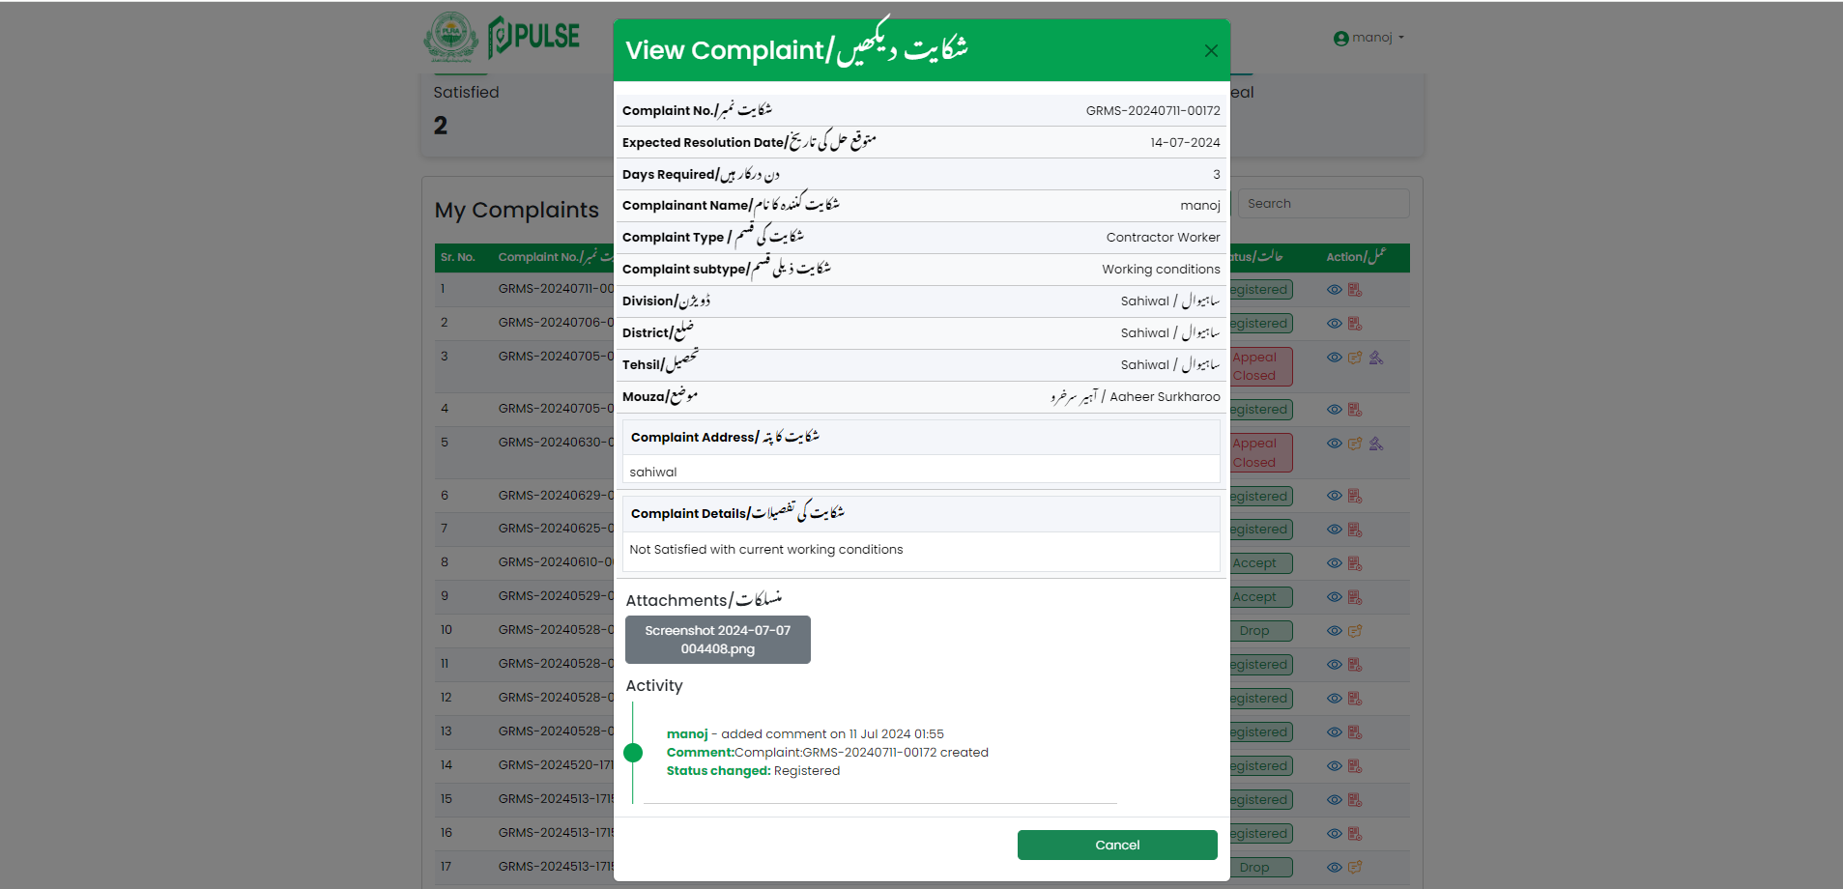

Click here to close popup

Figure 15:View Complaint

Below details of the complaint will be displayed:

* Complaint No
* Expected Resolution Date
* Days Required
* Complainant Name
* Complaint Type
* Complaint Subtype
* Division
* District
* Tehsil
* Mouza
* Complaint Address
* Complaint Details
* Attachments
* Activity

### Feedback

Upon clicking the  icon, a pop-up window will appear prompting user to give feedback on the respective complaint. The user will provide a star rating and input a review in text format before clicking on the **"Submit"** button**.**

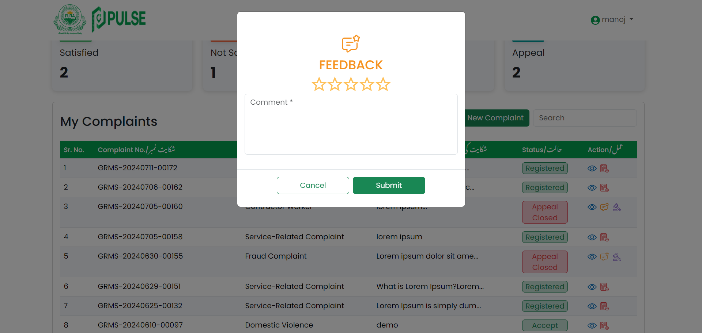

Select Rating

Submit Feedback

Enter Review

Figure 16: Feedback on Complaint

### Appeal

Upon clicking the  icon, a pop-up window will appear prompting the user to enter a comment about the appeal. The user will enter a comment and click on **“Yes, Appeal”** button.

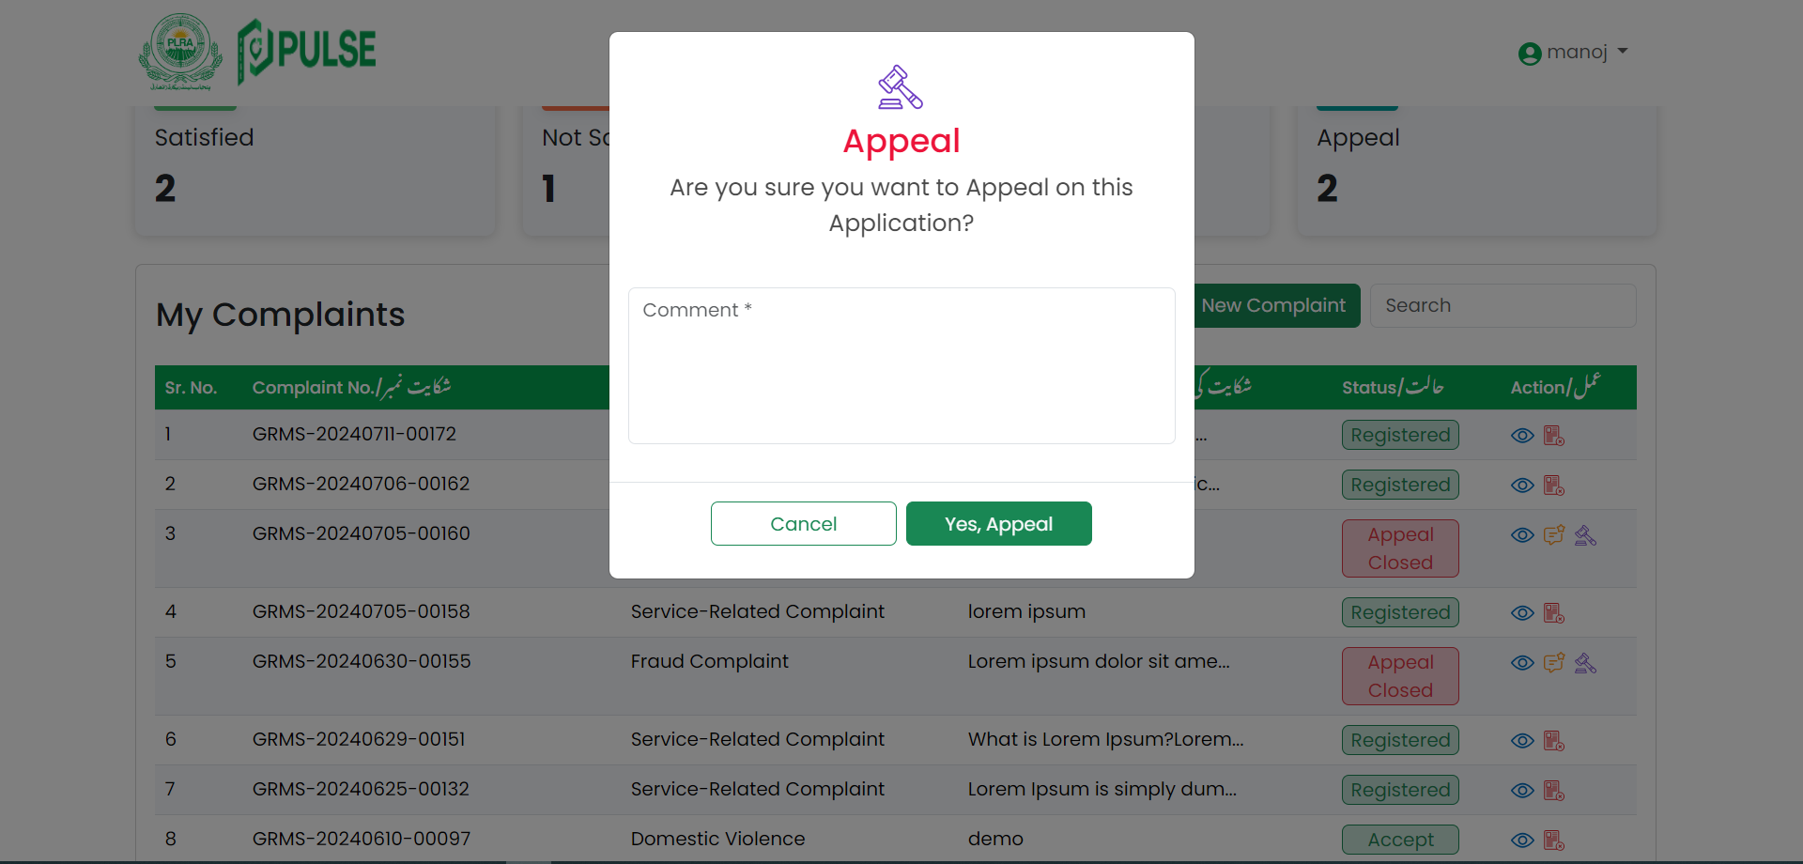

Cancel Appeal

Confirm Appeal

Enter Comment

Figure 17: Appeal on Complaint

### Drop Complaint

Upon clicking the  **icon**, confirmation pop up will appear. prompting the user to enter a comment about the drop. The user will enter a comment and click on **“Yes, Drop”** button.

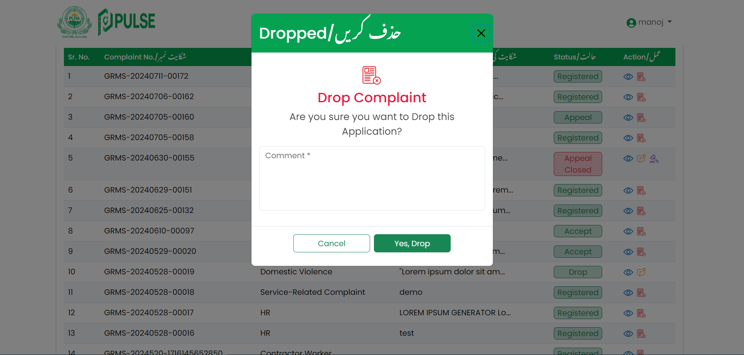

Enter Comment

Confirm Drop Complaint

Cancel Drop Complaint

Figure 18: Drop Complaint

## New Complaint

To register a new complaint, user will click on the **“New Complaint”** button placed on the **My Complaints** section as shown below:



Click here to register complaint

Figure 19: New Complaint

Clicking on **"New Complaint"** will open a new interface where the users can submit a new complaint by filling out the provided form as shown below:

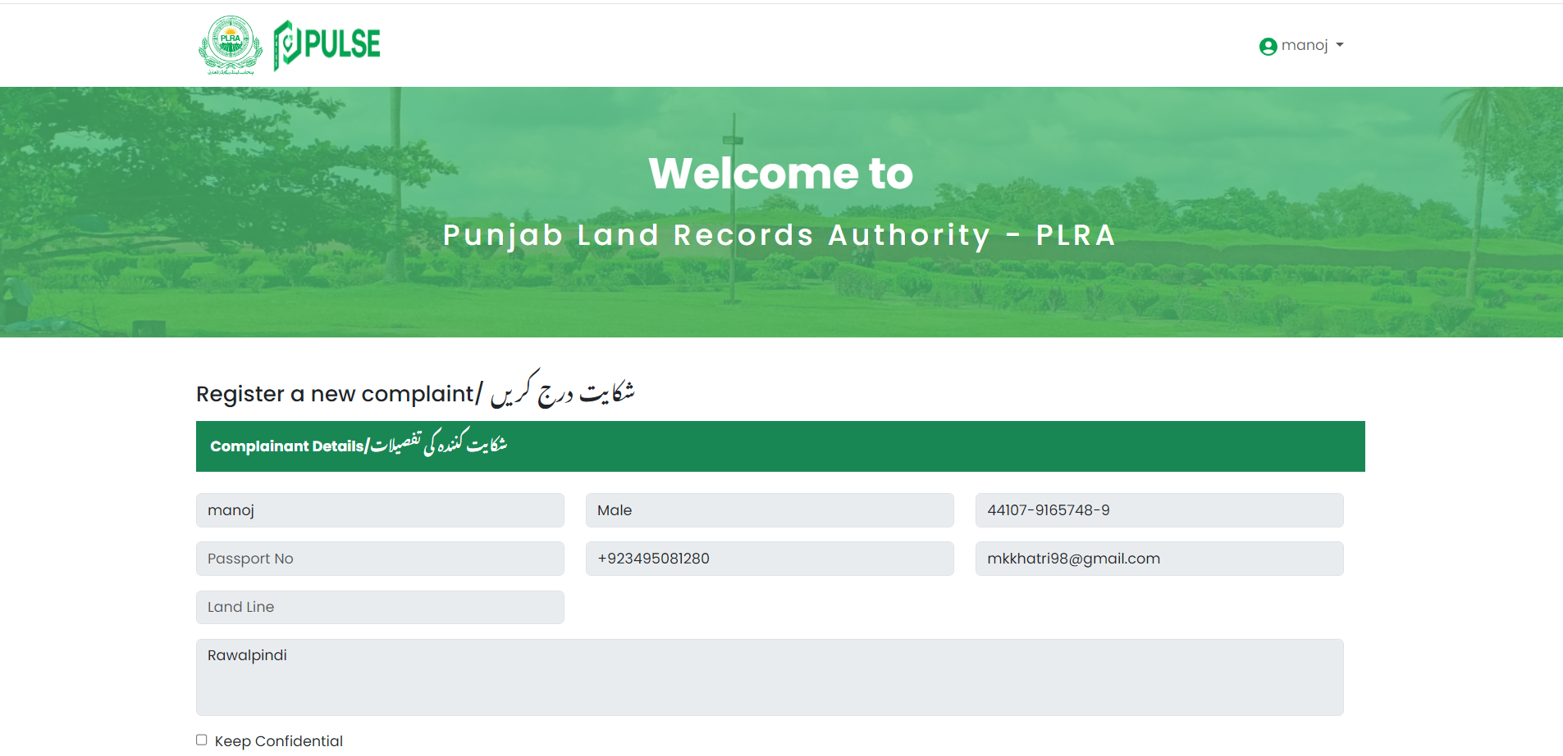

44xxy – xxxxxxx - xxxx

Abc12@gmail.com

03xx - xxxxxxx

Fill the required fields

Check this to keep information confidential

Figure 20: Register New Complaint - 1

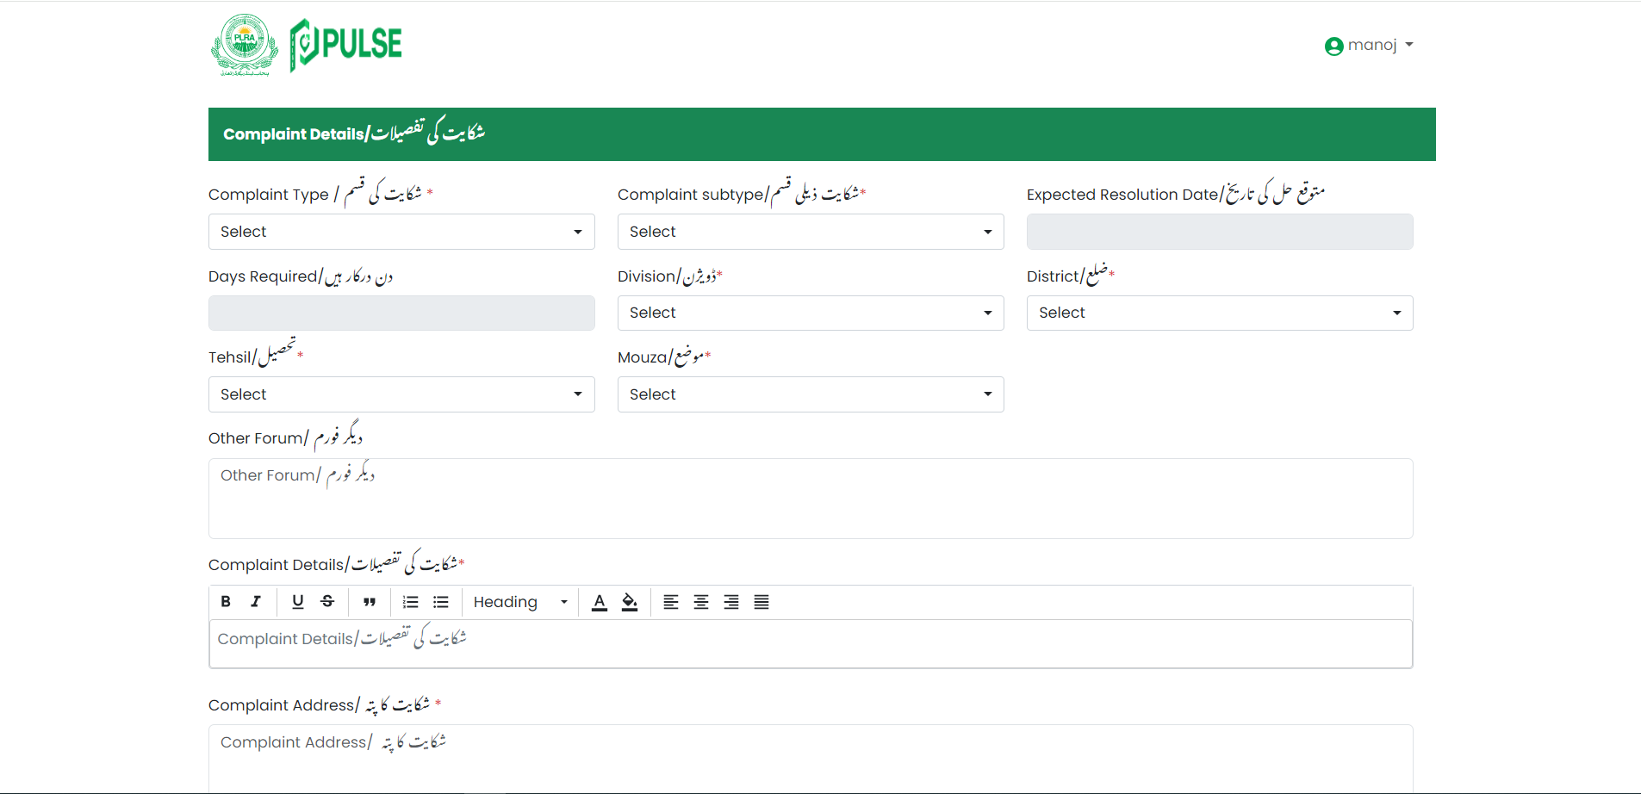

Fill the required fields

Figure 21: Register New Complaint - 2

Fill the required fields

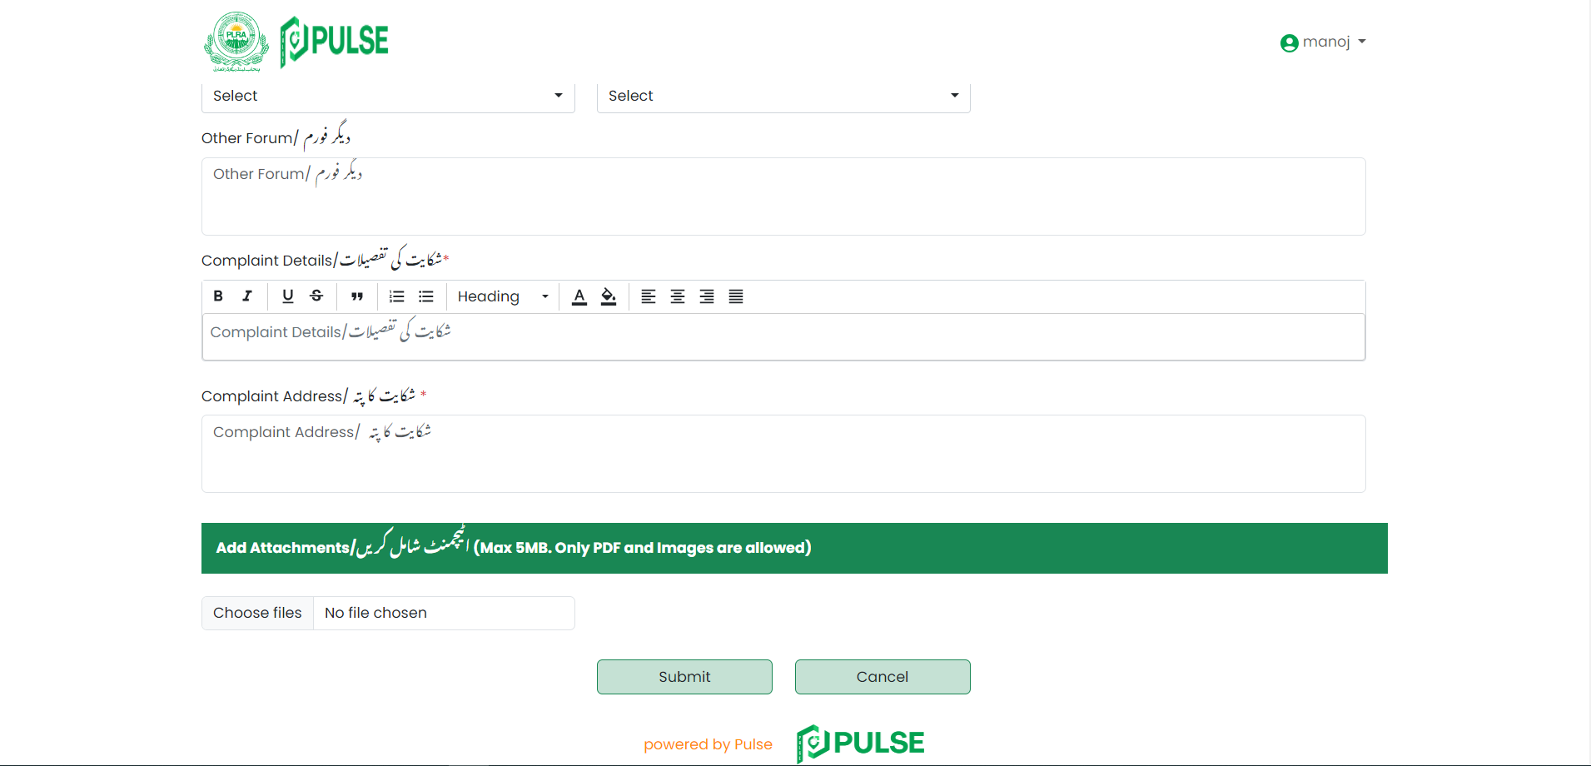

Click here to **Cancel** New Complaint

Click here to **Submit** form

Figure 22: Register New Complaint – 3

The following complainant details will be auto populated and displayed in the complaint registration form:

**Complainant Details**

* **Complainant Name**
* **Gender**
* **CNIC**
* **Passport No**
* **Mobile No**
* **Email**
* **Land Line**
* **Address**

If the user wants to keep the above information confidential from the complaint handler or approver, they should check the **"Keep Confidential"** checkbox. The user will provide the following complaint details

**Complaint Details**

* Select **Complaint Type**
* Select **Complaint Subtype**
* **Expected Resolution Date (Auto filled)**
* **Days Required (Auto filled)**
* Select **Division**
* Select **District**
* Select **Tehsil**
* Select **Mouza**
* Enter **Other Forum**
* The "Other Forum" field will be filled in accordingly If the complaint has been logged with any other forum, such as a committee or court etc.
* Enter **Complaint Details**
* Enter **Complaint Address**

**Add Attachment**

* Choose File **(Max 5MB, Only PDF and Images are allowed)**

After providing the above information, click on the **"Submit"** button to successfully register the complaint.

## Update Profile

To update the profile details, click on the  icon located on the top right corner and select **Profile** as instructed below:

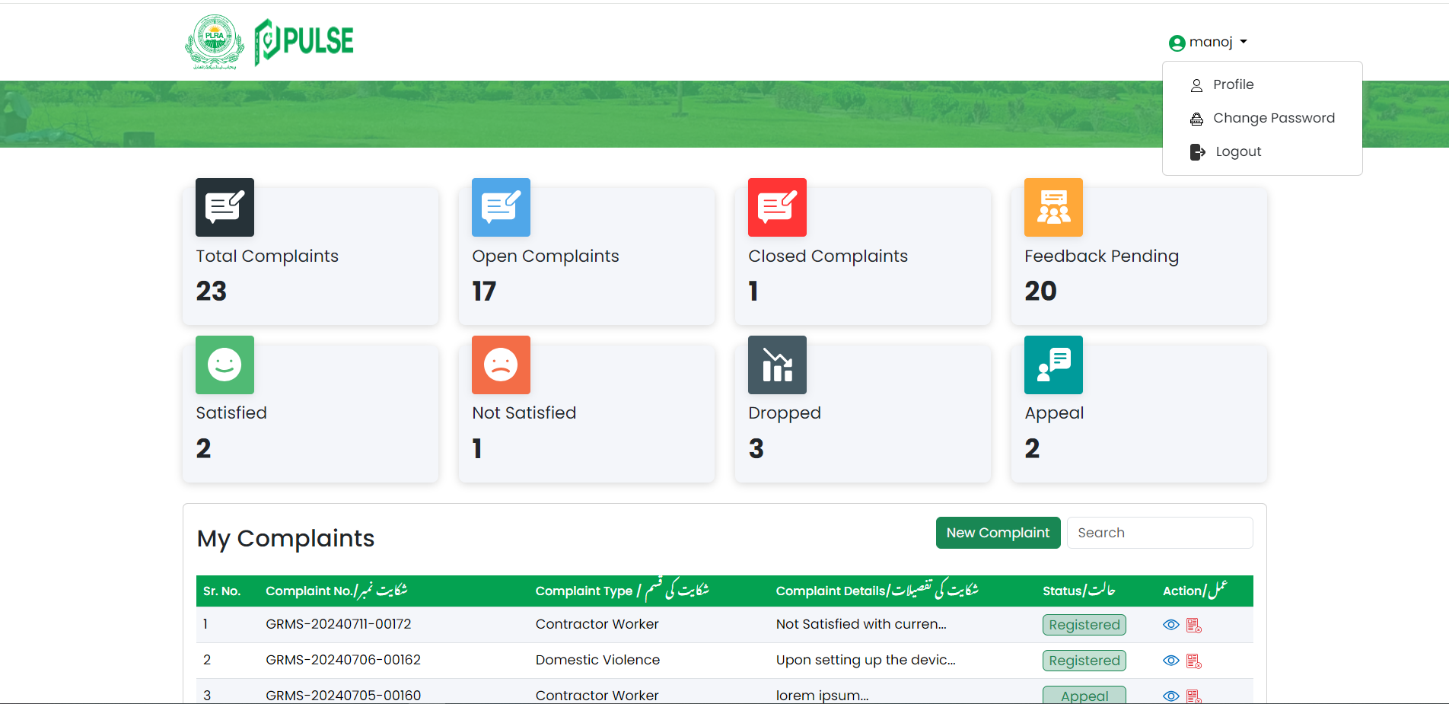

Click here to update profile

Figure 23: Update Profile

After selecting **"Profile",** a new interface will appear displaying the current profile details. Only below details will be editable:

* Name
* Gender
* Address

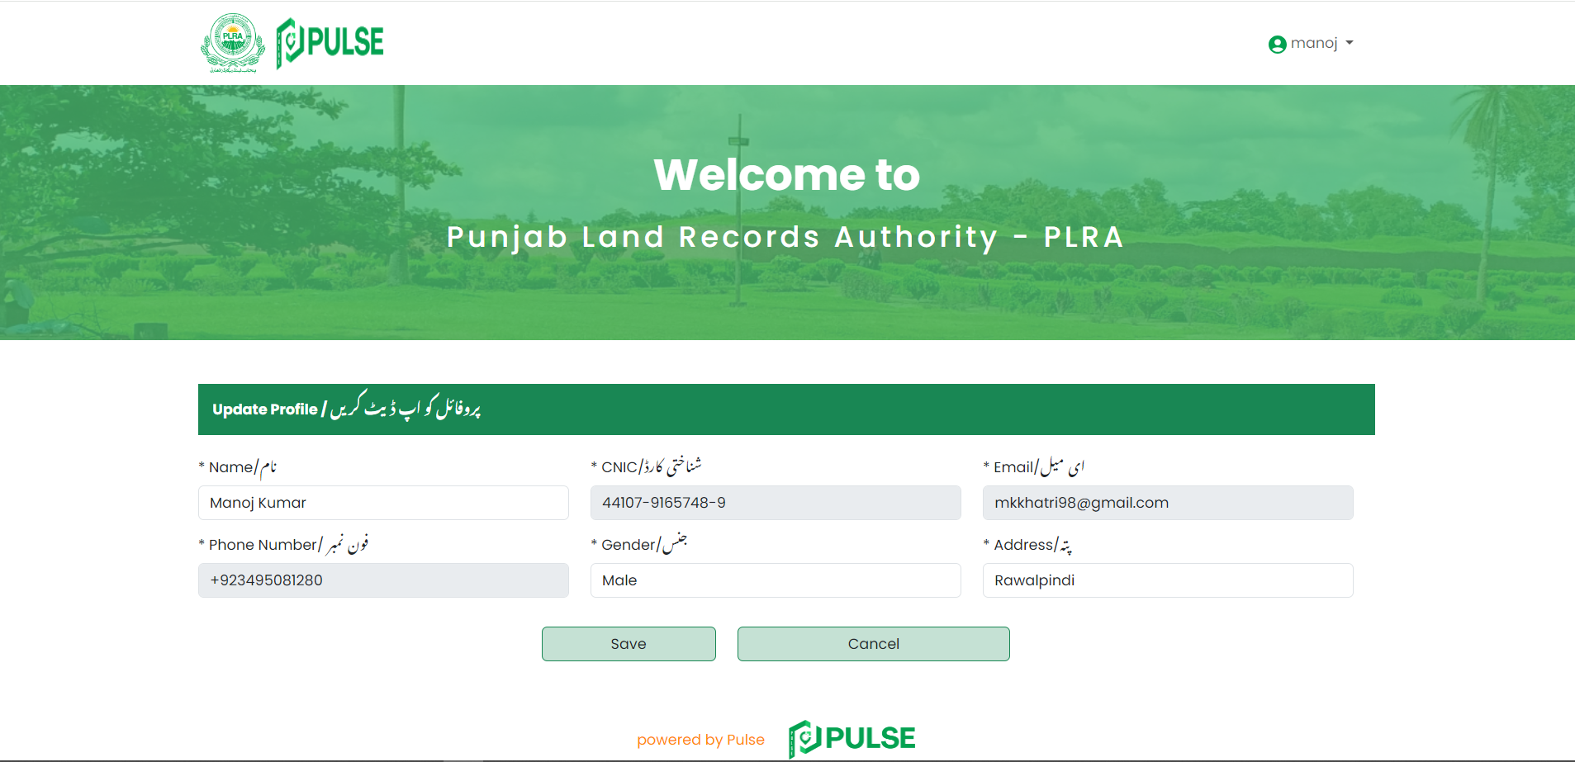

03xx - xxxxxxx

Click here to save changes

Abc12@gmail.com

44xxy – xxxxxxx - xxxx

Profile Details

Figure 24: Update Profile Fields

After updating the information, click on **"Save"** to apply the changes.

## Change Password

To update the profile details, click on the  icon located on the top right corner and select **Change Password** as instructed below:



Click here to **change password**

Figure 25: Change Password

After selecting **"Change Password,"** a pop-up will appear on the screen prompting the user to enter and confirm the new password as shown below:

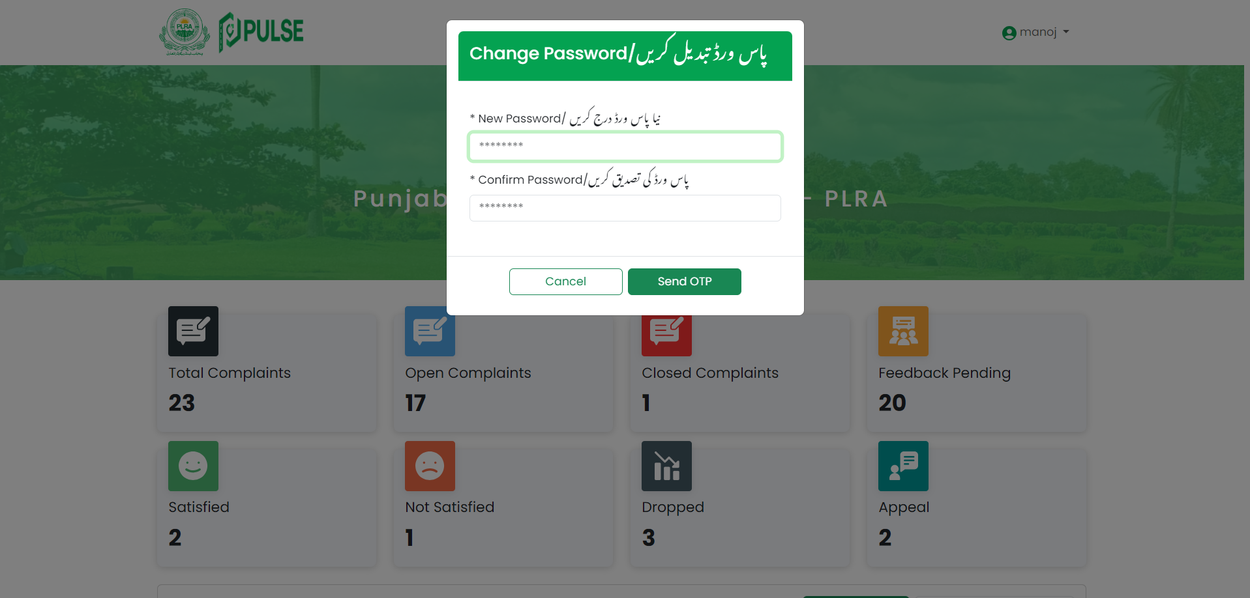

Click here to close pop up

Click here to **Send OTP**

Enter and confirm new password

Figure 26: Enter New Password

After entering the new password, the user will click on **"Send OTP"** to send the verification code to their registered mobile number.

The user will enter the **6-digit OTP** received on their phone number. If the OTP is not received, the user can resend it when the resend timer is ended. Once the entered OTP is verified, the user's password will be successfully changed.

## Logout

The user will opt for logout when he wants to exit from the portal. To logout from the portal, click on the  icon located on the top right corner and click **Logout** as instructed below:



Click here to logout

Figure 27: Logout

Selecting **"Logout"** will trigger a confirmation message. Users can then confirm their choice by clicking **"Yes"** to log out of the portal:

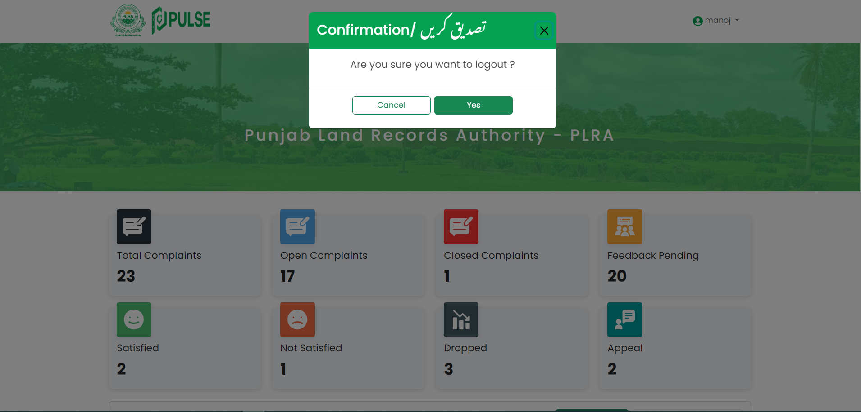

Click here to confirm logout

Figure 28: Confirm Logout